ACCRETION INFORMATION

To learn about accretion, click on:

http://earthquake.usgs.gov/learning/glossary.php and then click on “Accretionary Wedge.” Look for the tan colors – those are sediments or stuff on the ocean floor that have been added to the edge of the continent (shown in pink). If you look carefully you can see little stripes of green in the accretionary wedge – those are chunks of the oceanic crust that have been scraped off, too.

To learn more about how accretion works to make a continent grow, check out:
http://www.classzone.com/books/earth_science/terc/content/visualizations/es0808/es0808page01.cfm?chapter_no=visualization

Check out this video by clicking on the little film icon in the lower left corner:
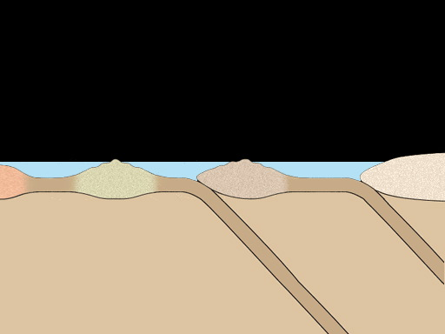

Check out these images from the Natural History Museum in NY, with different colored sand inside working convergent model. This model shows you how different material from the ocean floor is added to the edge of the continent.
