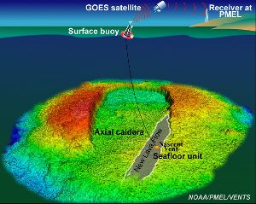
The Axial Seamount is a volcano that is sitting on a mid-ocean spreading ridge, and it’s also over a hotspot. To see where it is, click on this link:

http://vulcan.wr.usgs.gov/Glossary/PlateTectonics/Maps/map_juan_de_fuca_ridge.html

To learn about the Axial Seamount, click on:

http://www.pmel.noaa.gov/vents/nemo/explorer/panos/vrcaldera.html
This will give you a view of what the caldera looks like,

Then, click on:
http://www.pmel.noaa.gov/vents/nemo/explorer/multimedia.html
to get a list of available files. Ones to check out are:
Fly-through Animations – Axial Seamount, and Axial Caldera
Virtual Reality Panoramas – Axial Seamount and Axial Caldera

Also in Videoclip from ROPOS, check out:
Rumbleometer View and Lava drips. Read the story of the Rumbleometer at:
http://www.pmel.noaa.gov/vents/nemo/explorer/rumble.html

